**Task 6: Biodiversity in a Local Ecosystem**

Scientific Inquiry

Name: ­­_______________  
Teacher: ______________

Mark: ­­­­______  
Comment: __________________ ______________________________________________________________________________

**Assessment type:** Science Inquiry

**Conditions**

Period allowed for completion of the task

Observations: two periods

Analysis of data: two periods   
Validation: one period (30 mins)

**Task weighting**

5% of the school mark for this pair of units

**Background:**

**What is biodiversity?**

Biodiversity can be defined on a variety of levels. Ecosystem biodiversity refers to the variety of habitats within a particular area or region. This inquiry focuses on species biodiversity, or the variety of plants and animals in a particular habitat. On a more complex level, genetic biodiversity looks at the variety of characteristics within a particular species.

The opposite of species diversity is monoculture. The term monoculture refers to a situation in which only one species occupies a particular area or region. Examples of man-made monocultures include lawns and farms (such as wheat fields or pumpkin patches).

**Why is biodiversity important?**

Habitats that have a greater variety of different species of plants and animals have a greater biodiversity. These habitats are also healthier and more stable. One reason diverse communities have greater levels of health is that organisms of the same species tend to be more spread out. This reduces the ability of a disease to spread throughout a habitat. Additionally, if a certain type of species of tree or plant does become infected, the other species will remain and continue to provide the habitat components for the organisms in that area.

In an area consisting of monoculture, an area with only one type of plant species growing, the plants are more susceptible to disease and other stresses because they are all the same and less spread out (no other types of plants between them). As a result, [the entire habitat can be dramatically altered when impacted by disease or other stresses]. Human-made monocultures (crops, etc.) are created to make harvesting easier. However, they typically require larger amounts of pesticides and

herbicides (to prevent diseases and/or “weeds”) and larger amounts of energy and labour to maintain before harvesting.

**Pre-Observation Data:**

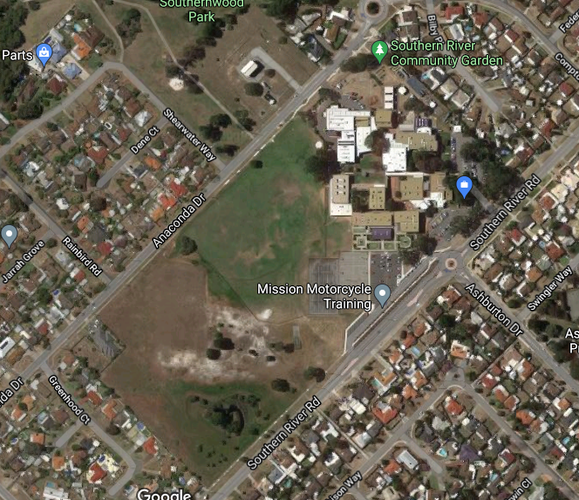

1. Identify on the school map the two locations (chosen by the class) that have the greatest potential of biodiversity. (2 marks)

To compare the biodiversity’s of the two sites you will have to mark out two plots and collect observations at both. You will have to designate the plots with flagging tape and pegs.

1. Write a hypothesis for this investigation.

_____________________________________________________________________________________________________________(2 marks)

1. Describe how you and the class are going to keep your observation fair. What do you need to do at each location?

_______________________________________________________________________________________________________________________________________________________________________ (2 marks)

1. List 3 risks associated with wildlife observations.

_______________________________________________________________________________________________________________________________________________________________________(3 marks)

1. Describe some precautions you and your peers are going to take to mitigate (reduce or stop) each of these risks.

_____________________________________________________________________________________________________________________________________________________________________________________________________________________________________________________________________________________________________________________________________________________(3 marks)

**Part One: Vegetation Survey**

Follow these steps while filling in the attached *Vegetation Survey* sheet.

1. Locate the area for your plot in the first location.
2. Accurately measure and outline your plot.
3. Search the area for grass. Be sure to tally the different species of grass and take pictures if you are unsure of the variety. If you find more than one variety of grass estimate the percentage of the plot covered by each type.
4. Now look for flowers. Are there any invasive species of flower? Mark each type in the Tally of Different Species column and tally the total number of invasive flowers in the Tally of All Plants Found Section.
5. Repeat step 4 for native and non-native flowers.
6. Repeat step 4 and 5 for Thick Ground Cover, Thick Brush and Bushes, Loosely Spread Out Shrubs or Bushes, Trees and Fungus, Mosses or Lichens.

Remember to tally different species as well as the total number of all plants found for each plant section.

1. Now complete steps 1 to 6 at the second location.

**(Diversity calculations will be completed in class)**

**Part Two: Wildlife Survey**Follow these steps while filling in the attached *Wildlife Biodiversity Index Data Collection Document* sheet.

1. Locate the area for your plot in the first location.
2. Accurately measure and outline your plot.
3. Choose a location within the plot to complete the observation.
4. Find a comfortable position and remain quiet for a minimum of 2 mins to allow wildlife to return to the area (they may have been scared off by your movement into the area).
5. Begin a timer for ___mins and start the observation.
6. Only count and tally the animals found/observed ON SITE (and/or in their sample area).
7. Tally the total number of different species, the total number of each species and the total number of all species found/observed for each group of animals. (see SAMPLE Wildlife Biodiversity Index Data Collection Document below)

Complete steps 1 to 7 for second location.   
**(Diversity calculations will be completed in class)**

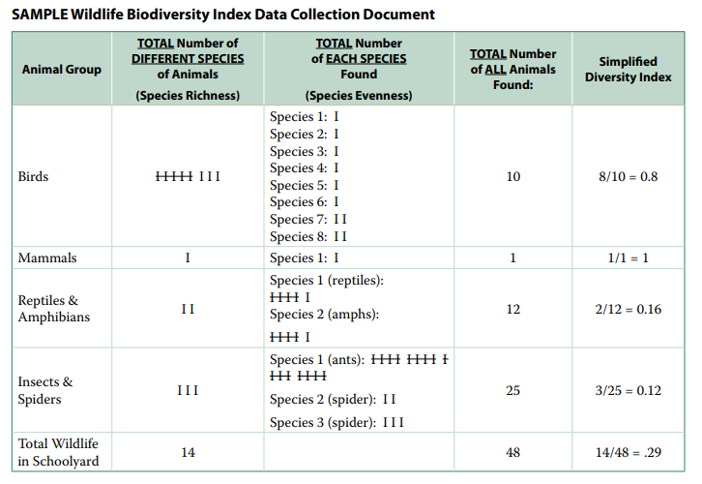

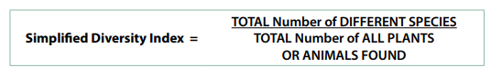**Part Three: Calculating Diversity**Calculate the Simplified Diversity Index for both the wildlife and vegetation data. Filling in your values on the *Wildlife Biodiversity Index Data Collection Document* and the *Vegetation Survey* document. The formula needed to calculate Simplified Diversity Index is on the right.

**Part Four: Post Observation Questions**

1. Define biodiversity in your own words.   
   ________________________________________________________________________________________________________________________(1 mark)
2. If we collected vegetation or animal data at a different time of the year, would we get the same Diversity Index calculations? Why or why not?

___________________________________________________________________________________________________________________________________________________________________________________________________________________________________________________________________________________________________________________ (2 marks)

1. An area with lots of weeds might score a high Diversity Index. Does a high Diversity Index always mean a habitat is healthy? Explain your answer.   
   ___________________________________________________________________________________________________________________________________________________________________________________________________________________________________________________________________________________________________________________________________________________________________________________ (3 marks)
2. What are some limitations or problems with random sampling to calculate diversity?

___________________________________________________________________________________________________________________________________________________________________________________________________________________________________________________________________________________________________________________________________________________________________________________ (3 marks)

1. Compare your data to a peer. Do you have similar values in the Vegetation Survey? Suggest reasons why or why not.   
   ______________________________________________________________________________________________________________________________________________________________________________________ (2 marks)
2. Compare your data to a peer. Do you have similar values in the Wildlife Survey and Simplified Diversity Index? Suggest reasons why or why not.   
   ______________________________________________________________________________________________________________________________________________________________________________________ (2 marks)
3. State your Simplified Diversity Index total from your *Vegetation Survey* for both your first and second location:

__________________ (1 mark) __________________ (1 mark)

1. Compare your *Vegetation Survey Data* from both locations. Is there a difference in overall DSI? Is there any similarities or differences within specific items? Give reasons for these similarities and differences.

_____________________________________________________________________________________________________________________________________________________________________________________________________________________________________________________________________________________________________________________________________________________________________________________________________________________________________________________________________________________________________________________________________________________________________________________________________________________________________________________________________________________________________________________________________________________________________________(6 marks)

1. State your Simplified Diversity Index total from your *Wildlife Biodiversity Index Data* for both your first and second location:

__________________ (1 mark) __________________ (1 mark)

1. Compare your *Wildlife Biodiversity Index Data* from both locations. Is there a difference in overall DSI? Is there any similarities or differences within specific animal groups? Give reasons for these similarities and differences.

_____________________________________________________________________________________________________________________________________________________________________________________________________________________________________________________________________________________________________________________________________________________________________________________________________________________________________________________________________________________________________________________________________________________________________________________________________________________________________________________________________________________________________________________________________________________________________________(6 marks)

